 | Document Name | AIX Migration from 7.1 to 7.2  Through VIO Repository
 | Document Number | MYL-UNX-SOP-AMTV - 001
 | Type of Document | Standard Operation Procedure
 | Revision No: | 1.0

Table of Contents
- PURPOSE 2
- SCOPE 2
  - In scope 2
  - Out of scope 2
- PREREQUISITES 2
- PROCEDURE 2
- VERSIO N HISTORY 13

PURPOSE
This document provides the steps to migrate the AIX OS version from AIX 7.1 to AIX 7.2.

SCOPE

In scope:
    - If OS version is going end of support, we will communicate it into Business and proposing OS upgrade to N-1 version release.
    - We will receive RITM from Application/ Database / Business unit for OS upgrade
    - If we receive email from Application/ Database / Business unit for OS upgrade, we will ask them to raise a RITM
    - We will raise a Normal change and based on SOP “MYGLO-SOP-IT-CHM-0001” we will get approval, then will implement it

Out of scope:
    - To check Proposed OS version is compatible to the database or the application.
    - Upgrading Database or application version to meet OS support version.
    - Business approval to upgrade OS, Application or Database

PREREQUISITES
  - Operating System AIX 7.2 Base ISO Images. We can download it from URL https://www.ibm.com/servers/eserver/ess/ProtectedServlet.wss#toggle
  - We can download TL Update from fix central URL https://www.ibm.com/support/fixcentral
  - VIO server should have enough free space in rootvg to create virtual media repository.
  - AIX Client LPAR must have 40% free disk space in rootvg

PROCEDURE
  - Login to the Aix LPAR (in which OS will upgrade) with MID and switch to root. Find out the VIO server, Vhost detail to map virtual optical device by issuing below command.
# echo "cvai" | kdb | grep vscsi
  - Create the virtual optical media device with SOP “MYL-UNX-SOP-VOD-001” and map to client AIX LPAR.
  - Boot the AIX LPAR in SMS mode, meanwhile login HMC with MID and take console of AIX LPAR.
In Manages Systems, Choose “0BPS202--SN068242P” by Type “2” in navigation key field
Note : 0BPS202--SN068242P (Manged Machine where the LPAR is present)
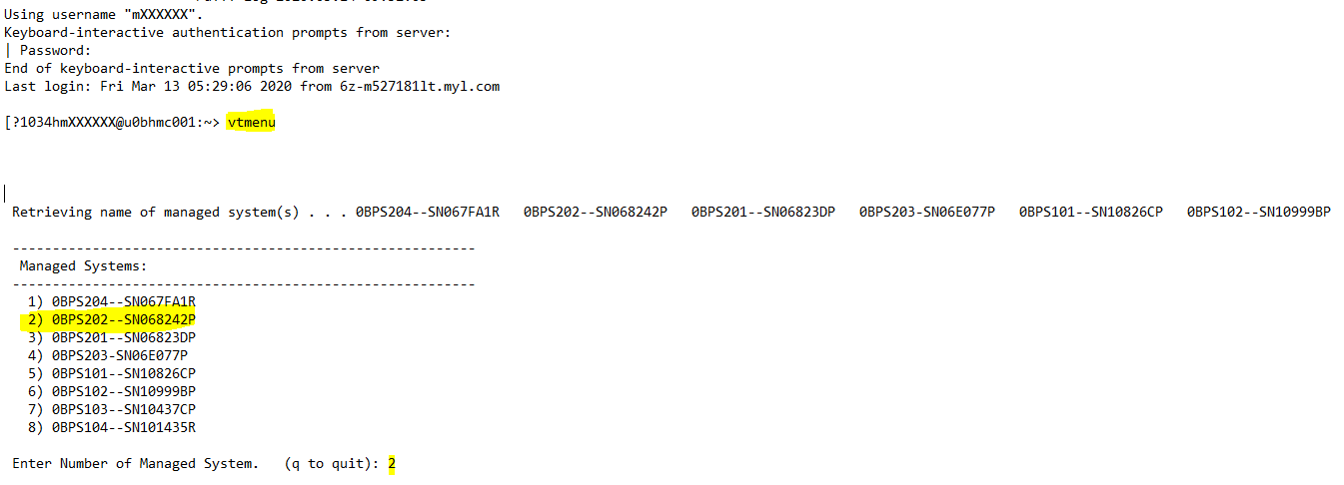
In Partitions On Manages System, Choose “0bps101_u0bnim001” by Type “1” in navigation key field.
Note : Select LAPR Name which you want to migrate.
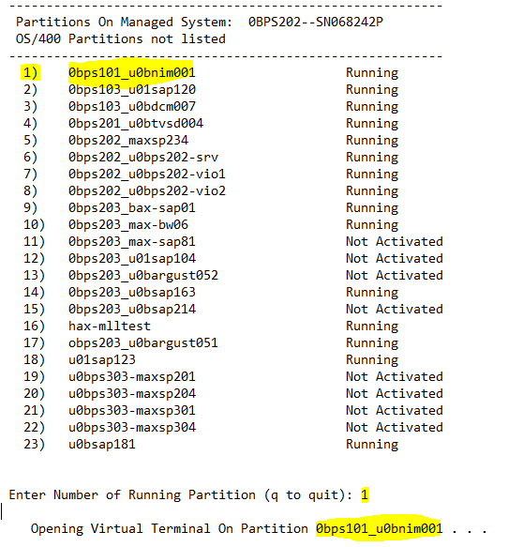

  - In SMS mode menu, Choose “Select Boot Options” by Type “5” in navigation key field
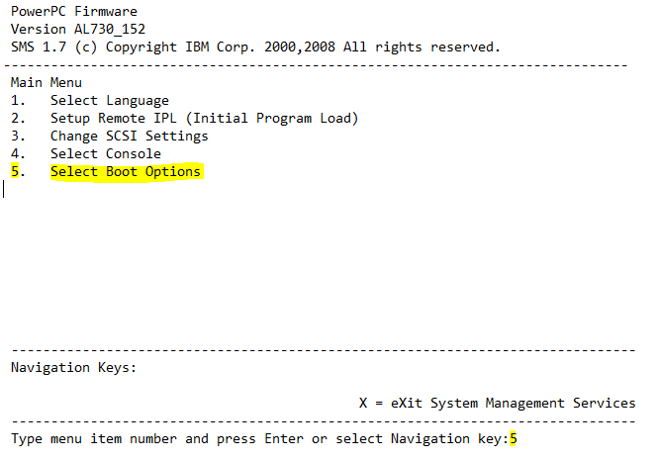

  - In Boot Options, Choose “Select Install/Boot Device” by Type “1” in navigation key field 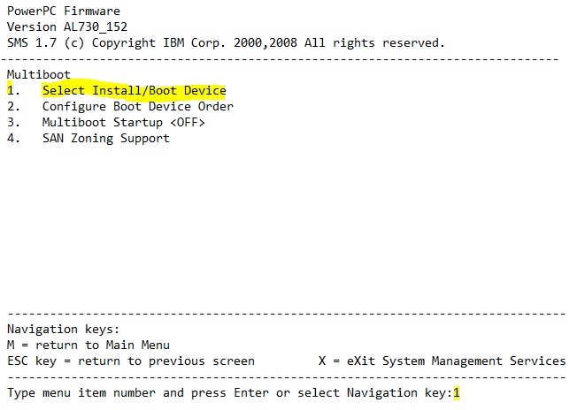

  - In Select Device Type options, Choose “List all Devices” by Type “7” in navigation key field
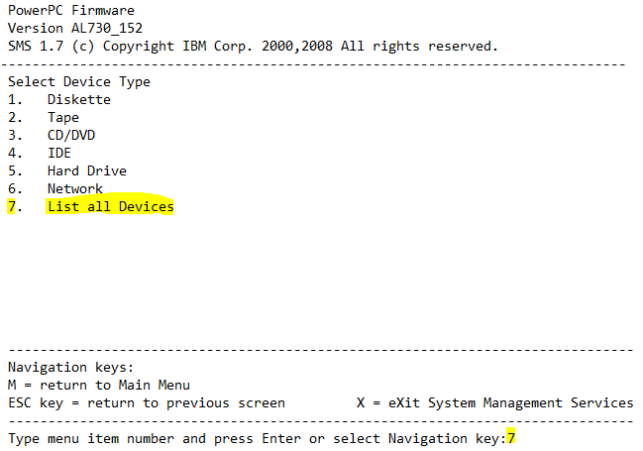

  - In Select Device menu, Choose CD-ROM by Type “2” in navigation key field 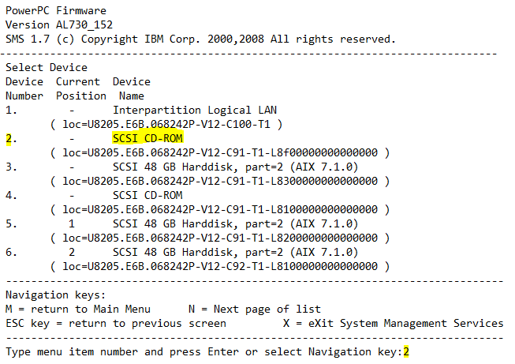
Note: SCSI CD-ROM is the virtual optical device mapped from VIO server

  - In Select Task Menu, Choose “Normal Mode Boot” by Type “2” in navigation key field
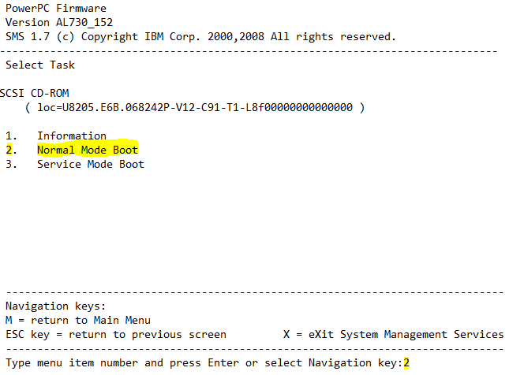

  - Save the Boot configuration and exit from SMS menu by Type “1” in navigation key field
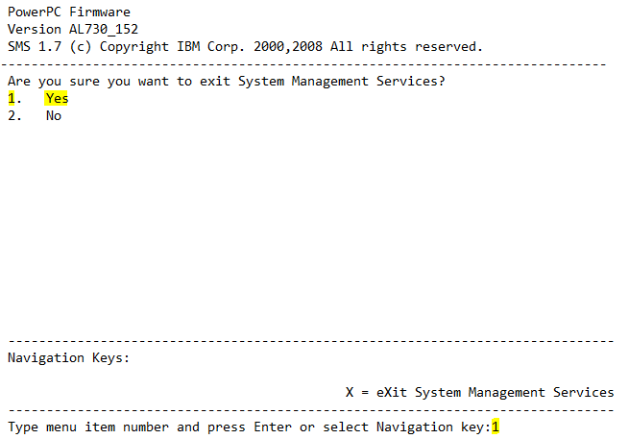
Note: Server will reboot after exit from SMS menu

  - Now server will boot with CD-ROM which having Bootable BOS image. Now Type a 1 and press Enter to use this terminal as the system console
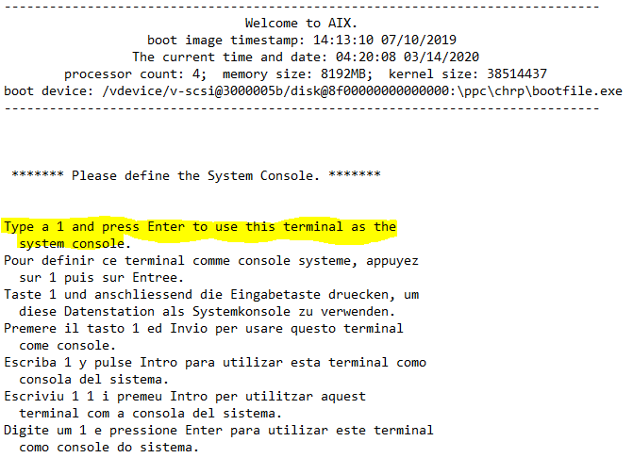

  - Select Installation Menu Language by Type 1 and press Enter to have English during install. Now BOS installation and Maintenance window will open
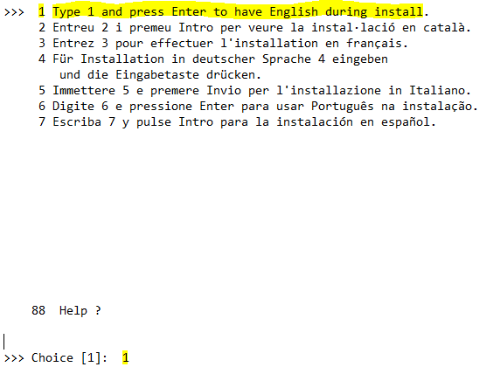

  - Type 2 and Choose “Change/Show Installation Settings and Install” in BOS Installation and Maintenance
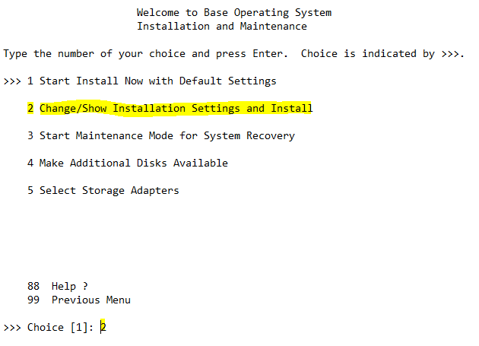

  - In the Installation and Settings window, Type 1 and press enter to select “System Settings”, then Change method of Installation menu will open.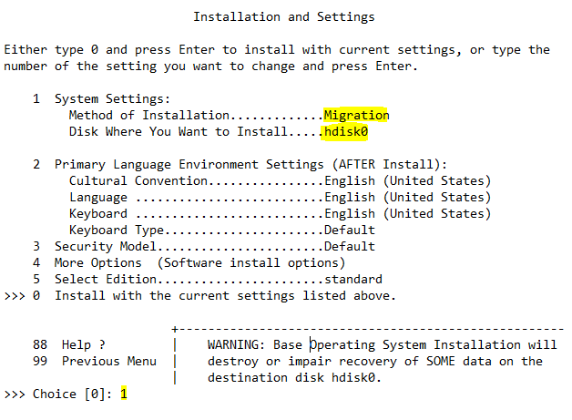

  - Change method of Installation menu, Type 3 and press enter to choose Migration Install. Now “Change Disks where You Wants to Install” menu will open
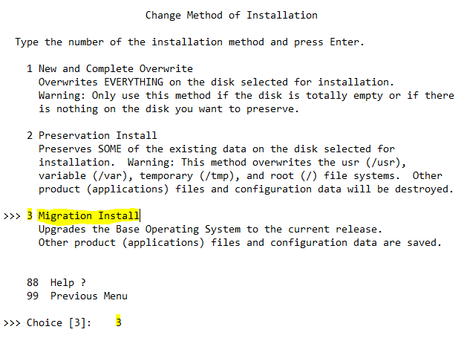

  - In Change Disks where You Wants to Install menu, Type “77” and press enter to Choose “Display More Disk Information”
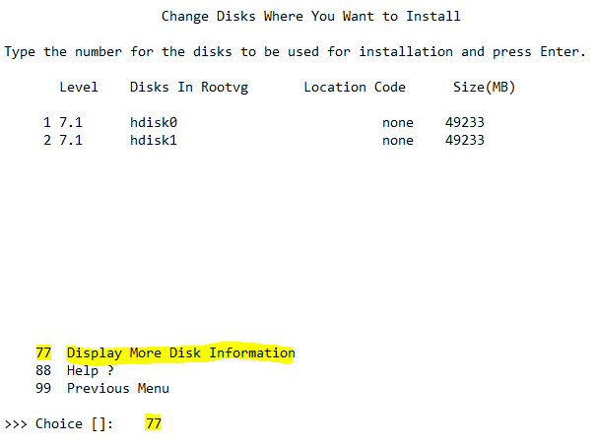

  - Identify the PVID of root vg disk, where we upgrade the OS. In this list Select option 1 So that you perform OS migration on hdisk0 and hdisk1 having old OS for roll back if migration fails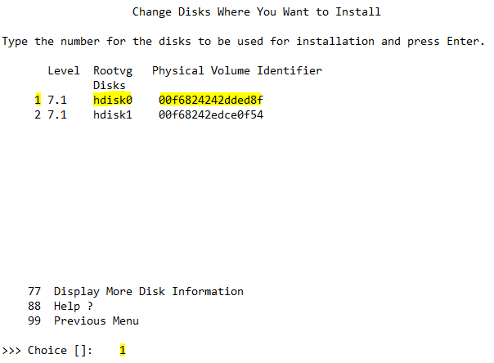

  - In the Installation and Settings window, Type “0” and press enter to select “Install with the current settings listed above”. 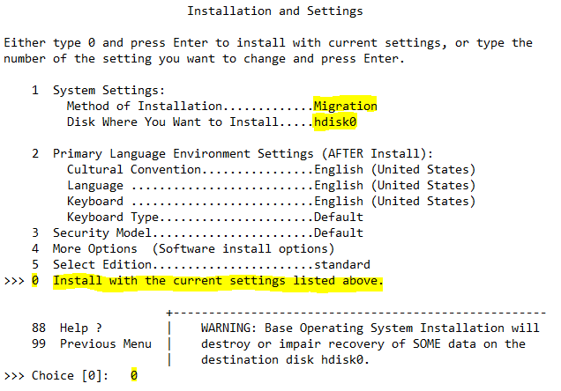

  - Review the summary and Type “1” and press enter to select “continue with Install”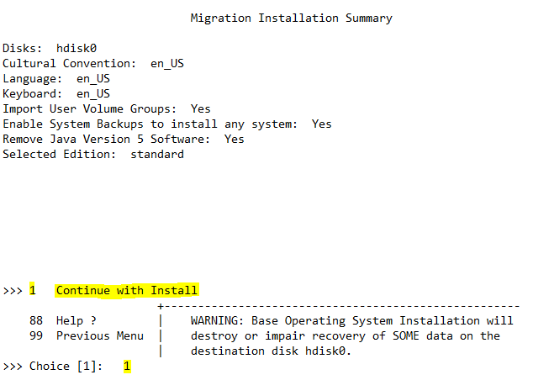

  - After completion file sets installation set the terminal type as vt100 and press enter.
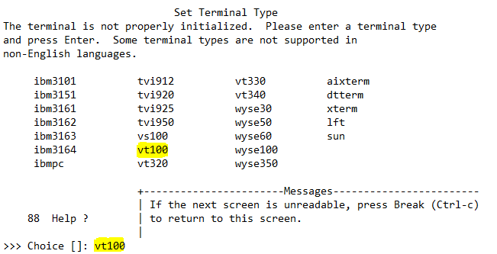
  - Once server came up. Check the OS level by issuing the below command.
# oslevel -s
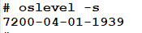

  - Check the known recommended maintenance levels by issuing below command.
# oslevel -rq
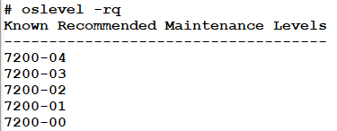
  - Check the known service packs by issuing the below command
# oslevel -sq
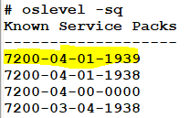
  - Once Application team confirm we can mirror the rootvg Disks by issuing the below command.
# mirrorvg rootvg hdiskX (Here hdisk4 is the new free physical volume)
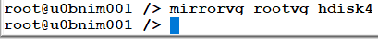
  - For rollback, change the bootlist and reboot the server, server will boot with Old OS version and it packages. Post we can Mirror the rootvg disks
Change the bootlist order by issuing the below command
# bootlist -m normal hdisk3 (Here hdisk3 is old rootvg physical volume)
Check the bootlist order by issuing the below command.
# bootlist -m normal -o
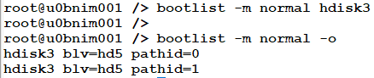

VERSION HISTORY

 | Prepared By | Reviewed by | Approved By
Name | Kenche Jayakrishna | Franklin K Dhas | Arunachalam G
Role | Unix L2 | SME | Senior Manager
Date | 16-MAR-2020 | 17-MAR-2020 | 27-MAR-2020
Version | 1.0 | 1.0 | 1.0

